CLEAN SLATE PROGRAM ADMINISTRATION CHECKLIST

- Clinic Establishment
  - Establish parameters with local judicial branches for clinic procedures.
  - Establish Funding Opportunities
  - Establish Clinic Dates and Times
  - Establish Clinic Staffing Needs
  - Establish Patient Base
- Ensure the clinical team has the following documents
- Clean Slate Tattoo Removal Clinic Volunteer Time Sheet
- Clean Slate Photographing Tattoo Procedure Sheet
- Clean Slate Characteristics Form
- Clean Slate Tattoo Removal Clinic Check-in Form
- Clean Slate Tattoo Patient Information Handouts
  - Parole Officer Referral Form
  - Clean Slate Tattoo Patient Education Flyer
  - Clean Slate Tattoo Removal Program—How to Use the Lidocaine Cream
- Physical Items for Clinic Set Up
  - Tape Measure
  - Device for Tattoo Photography (See Tattoo Identification Sheet for details)
  - Index Cards or Address Labels
  - Lidocaine
  - Saran Wrap
Clean Slate Tattoo Removal Clinic Volunteer Clinical Time Sheet
Week Of:

Clinic Name:

Clinic Address:
PROVIDER NAME | Start Time | End Time | Total Hours

Weekly Totals

PHYSICIAN SIGNATURE:

PHYSICIAN SIGNATURE:

PHYSICIAN SIGNATURE:

ATTENDING PHYSICIAN

Photographing the tattoos for laser tattoo removal

- All tattoos need to be photographed at each visit BEFORE and AFTER the laser is used for the removal.
- To photograph the tattoo, please use the study’s camera.
- Each tattoo photograph will need to be labeled with the following information, using either an index card in the background or an address label sticker.
Please record this information/ favor de anotar estos datos
- Participant id / id del participante
- Visit #/ # de la visita
- Date of visit/ fecha de la visita
- Size of tattoo (length* width, in centimeters)/ tamaño del tatuaje (Ancho*largo, en centimetros)

See below for examples/ Ejemplos a continuacion:
using index card next to area w/ tattoo
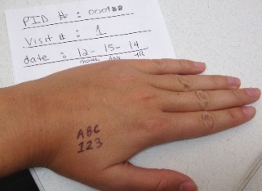

Using sticker label next to area w/ tattoo
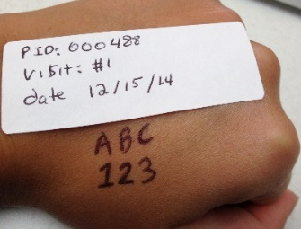

How to measure a tattoo/ Midiendo el tatuaje
Please use the tape measure to record the length and width of the tattoo in centimeters

Clean Slate Tattoo Removal Characteristic Chart
Week of:
CLIENT NAME | TATTOO  LENGTH (CM) | TATTOO  WIDTH (CM) | AREA TREATED  CM2 | LOCATION | ADVANCED TATTOO TYPE?  - S-- Large Size  - L. Location  - C--Color  - A-- Anesthesia | TREATMENT COST (S, M, L) | GANG

Clean Slate Tattoo Removal Clinic Check-In Form

Clinic Date:
SIGN IN SHEET
First Name, Last Name | Signature | Time In | Time Out

Clean Slate Tattoo Removal Clinic-How to Use the Lidocaine Cream

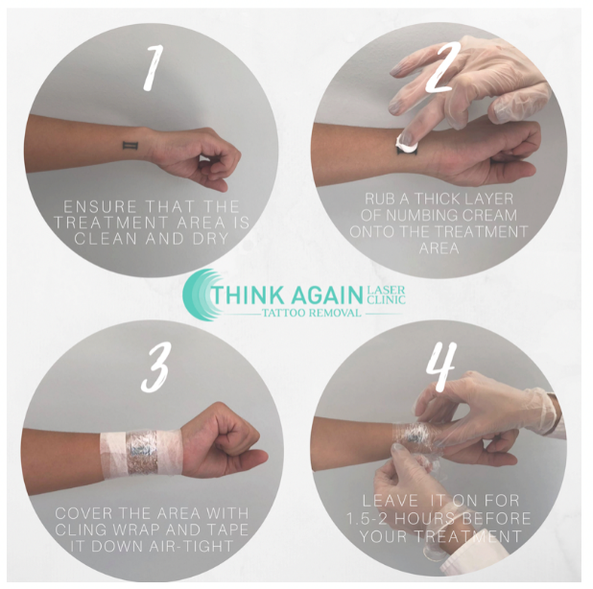
Clean Slate Tattoo Removal Clinic—How to Use the Lidocaine Cream

Step 1: Clean your skin

Step 2: Apply a thick layer of the numbing cream 2 hours before your treatment

Step 3: Cover the area with plastic wrap and tape it down tightly so the cream absorbs into the skin.

Step 4: Doctors will remove the cream at the clinic.

Clean Slate Tattoo Removal Clinic—How to Use the Lidocaine Cream

Step 1: Clean your skin

Step 2: Apply a thick layer of the numbing cream 2 hours before your treatment

Step 3: Cover the area with plastic wrap and tape it down tightly so the cream absorbs into the skin.

Step 4: Doctors will remove the cream at the clinic.

Clean Slate Tattoo Removal Clinic Referral Form

Patient Name: ________________________________________________________________________________________

Date of Birth: ___________________________________ Patient Phone Number: ________________________________

Address: _____________________________________________________________________________________________

City/State: ______________________________________________________ Zip: __________________________________

Preferred Contact Name and Number (if other than Patient): ______________________________________________

_______________________________________________________________________________________________________

Referring Parole Officer: ________________________________________________________________________________
Contact Number: ______________________________ Ext: __________ Email: ___________________________________

Patient Authorized for treatment: (Y)_____________________ (N)_____________________________________________

Comments: ____________________________________________________________________________________________

For questions about the Clean Slate Tattoo Removal program please contact us at:

Clinic Name:
Phone:
Email:
Fax #:

